**CS5590 APS – Python – Deep Learning Programming**

**Lab 4**

Fall 2018

UMKC

Kim-Ndor Djimadoumngar

1. **Introduction**

This is a report by Kim-Ndor Djimadoumngar for Assignment 2 of the Special Topic in Applied Programming Learning (APL) series: CS5590-0001 python and Deep Learning. My student ID is 6; my Lab ID is 7. The course is taught by Dr. Yugyung Lee and instructed by Saria Goudarzvand.

1. **Objectives**

The purposes of this lab are to:

* Implement text classification with CNN model
* Implement text classification with RNN/LSTM model
* Compare the results of the aforementioned models
* Implement the image classification with CNN.

1. **Approaches/Methods**

Pycharm Community Edition 2018 was used to create Python in order to implement the exercises.

1. **Results and discussion**

* **Exercise 1:** Implement text classification with CNN model

**Library and Data import**

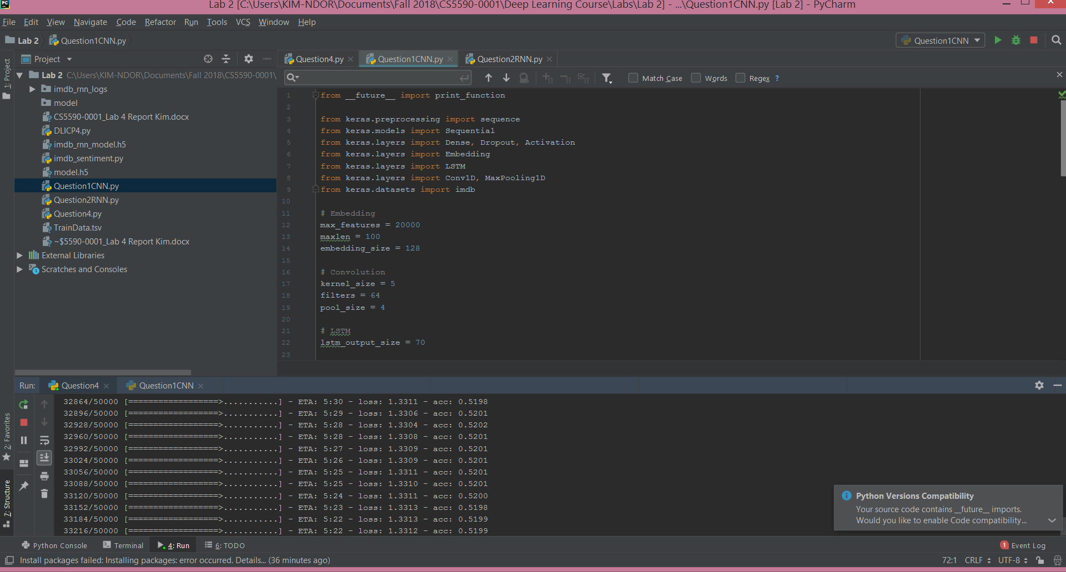

**Model specification**

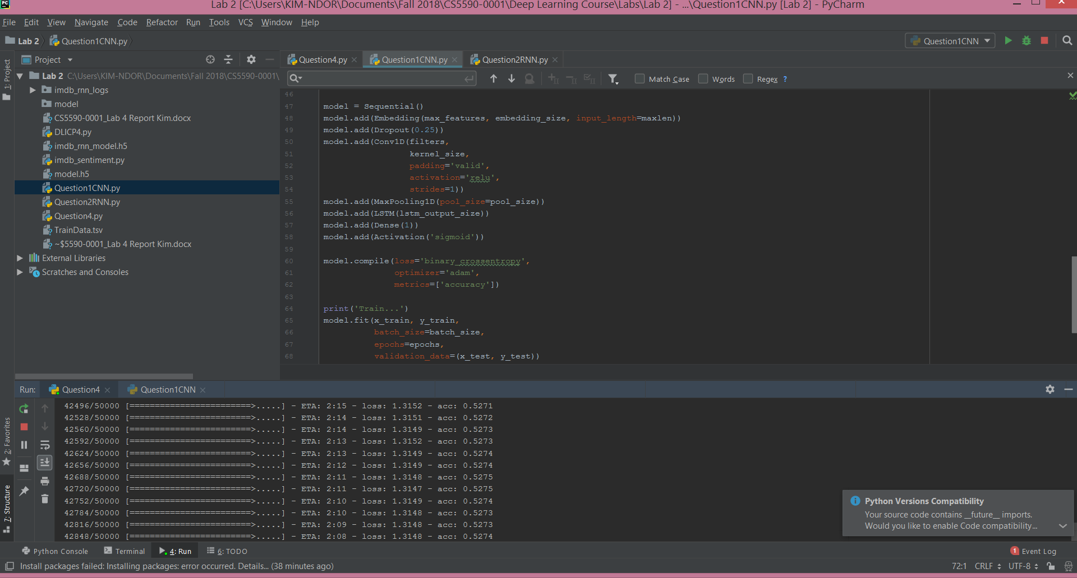

**The tabular output is presented below.**

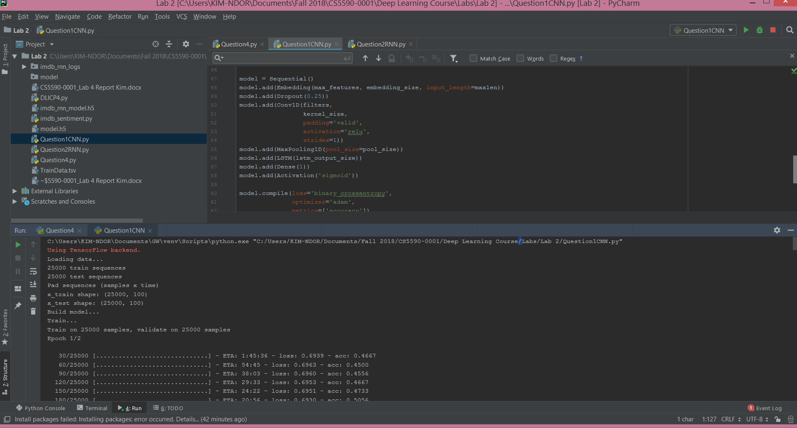

**Errors results**

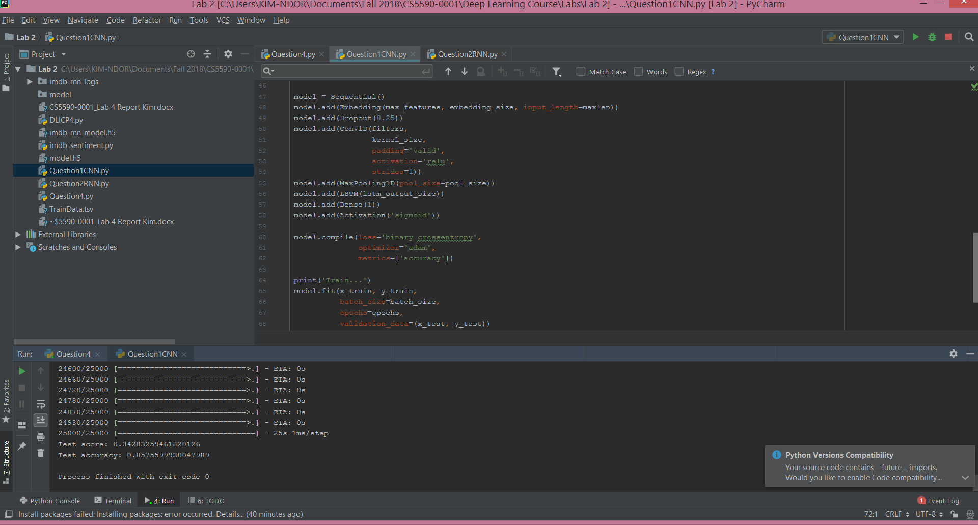

**Exercise 2: Implement text classification with RNN**

**Library and Data import**

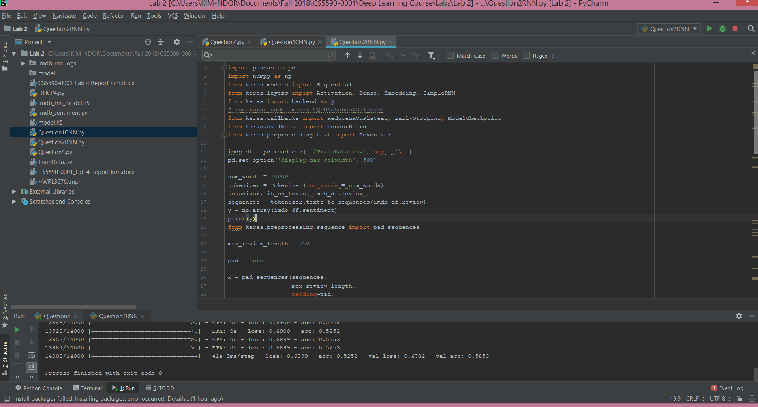

**Model specification**

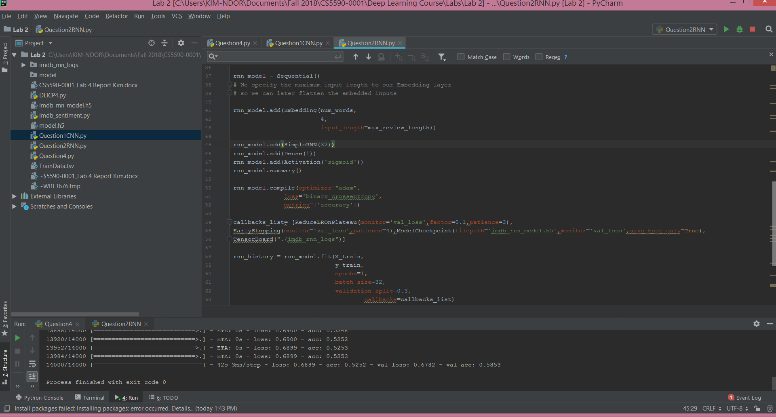

**The tabular output is presented below:**

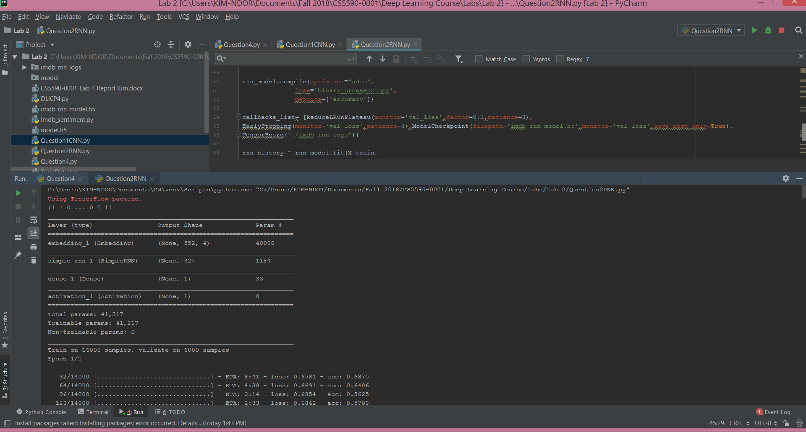

**Errors results**

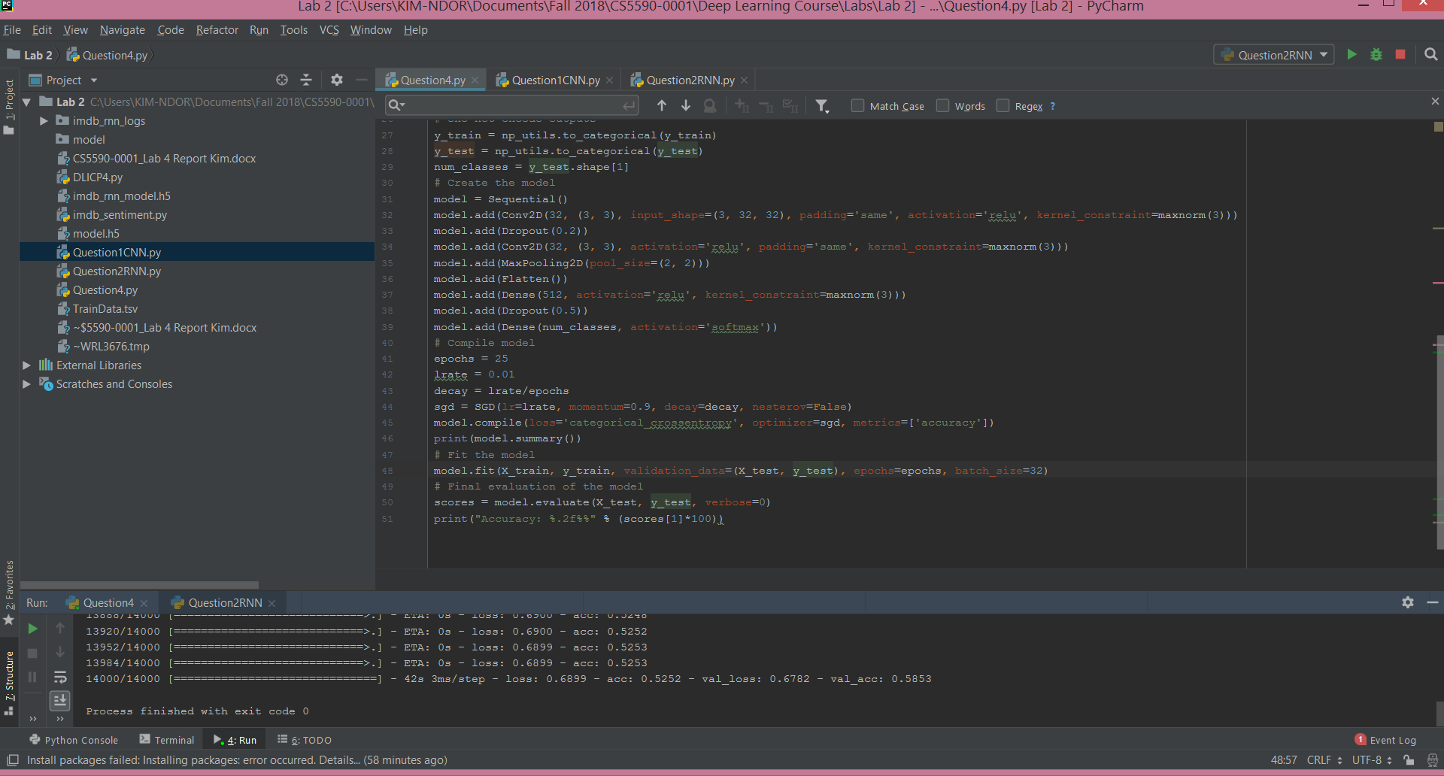

* **Exercise 3: Compare the results of the aforementioned models**

The text classification with CNN has a higher accuracy (85%0 than the text classification with RNN (55%).

* **Exercise 4:** Implement text classification with RNN model

**Library and Data import**

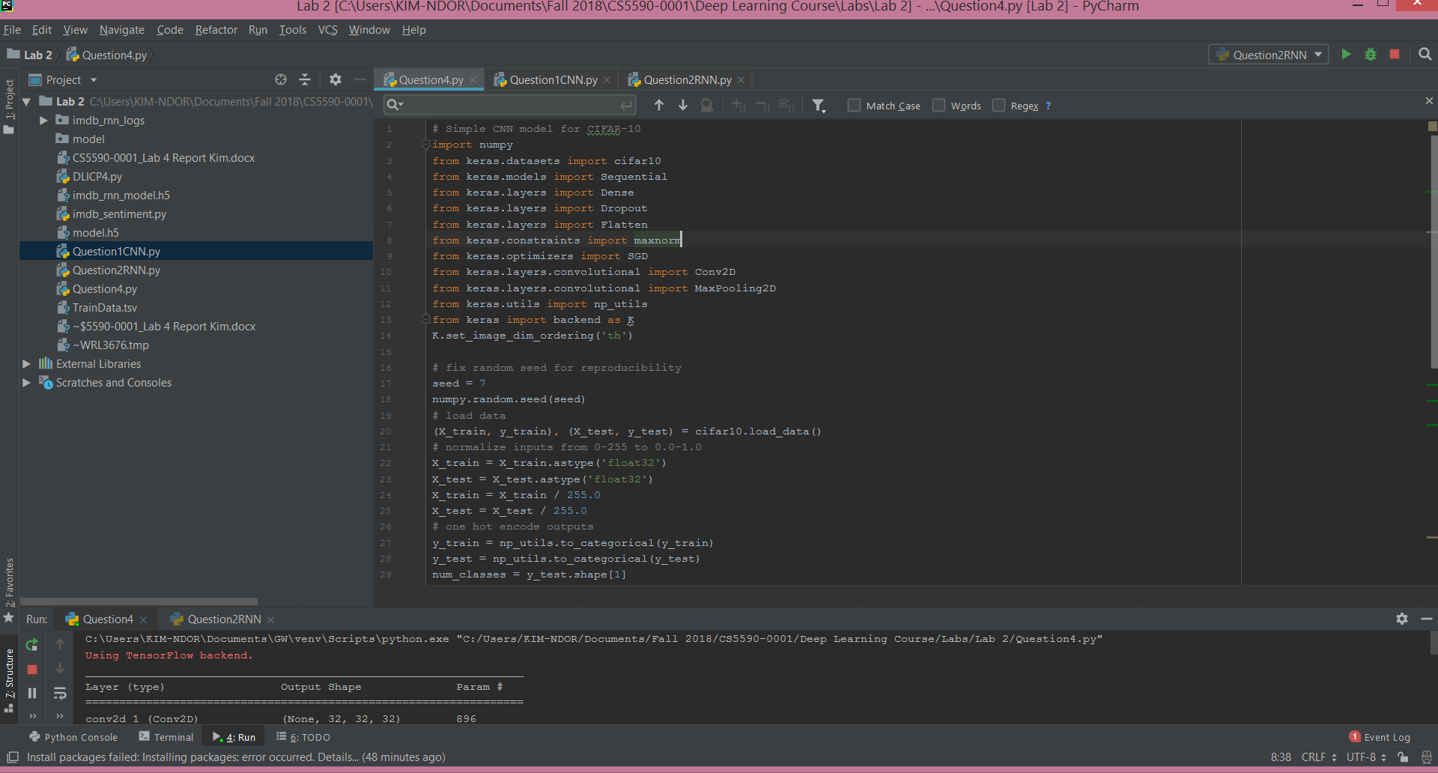

**Model specification**

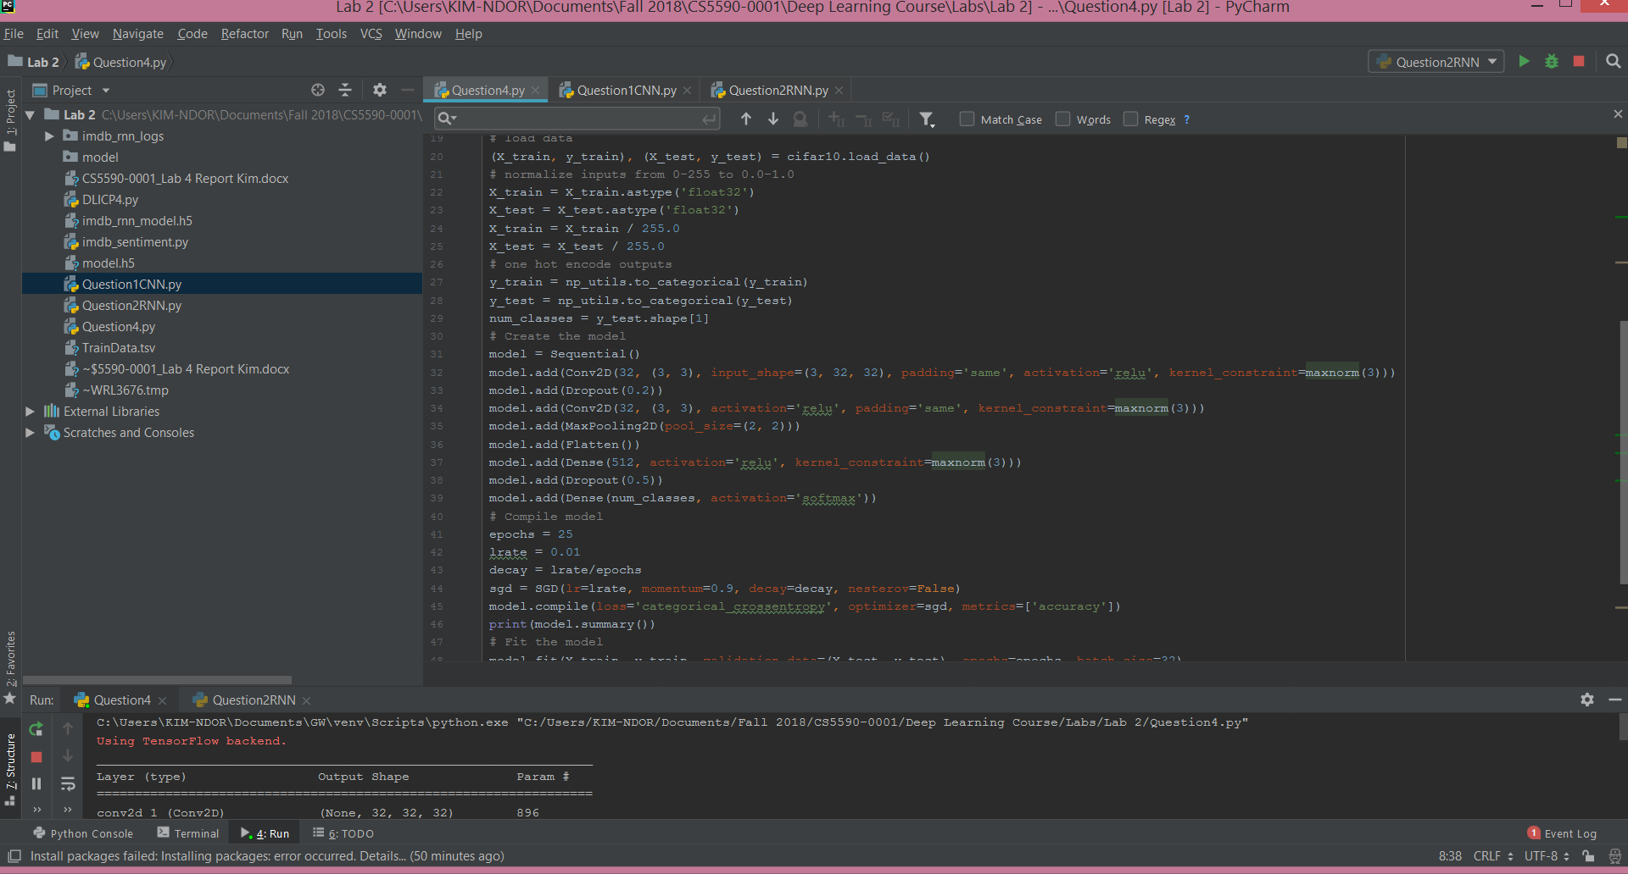

**The tabular output is as below:**

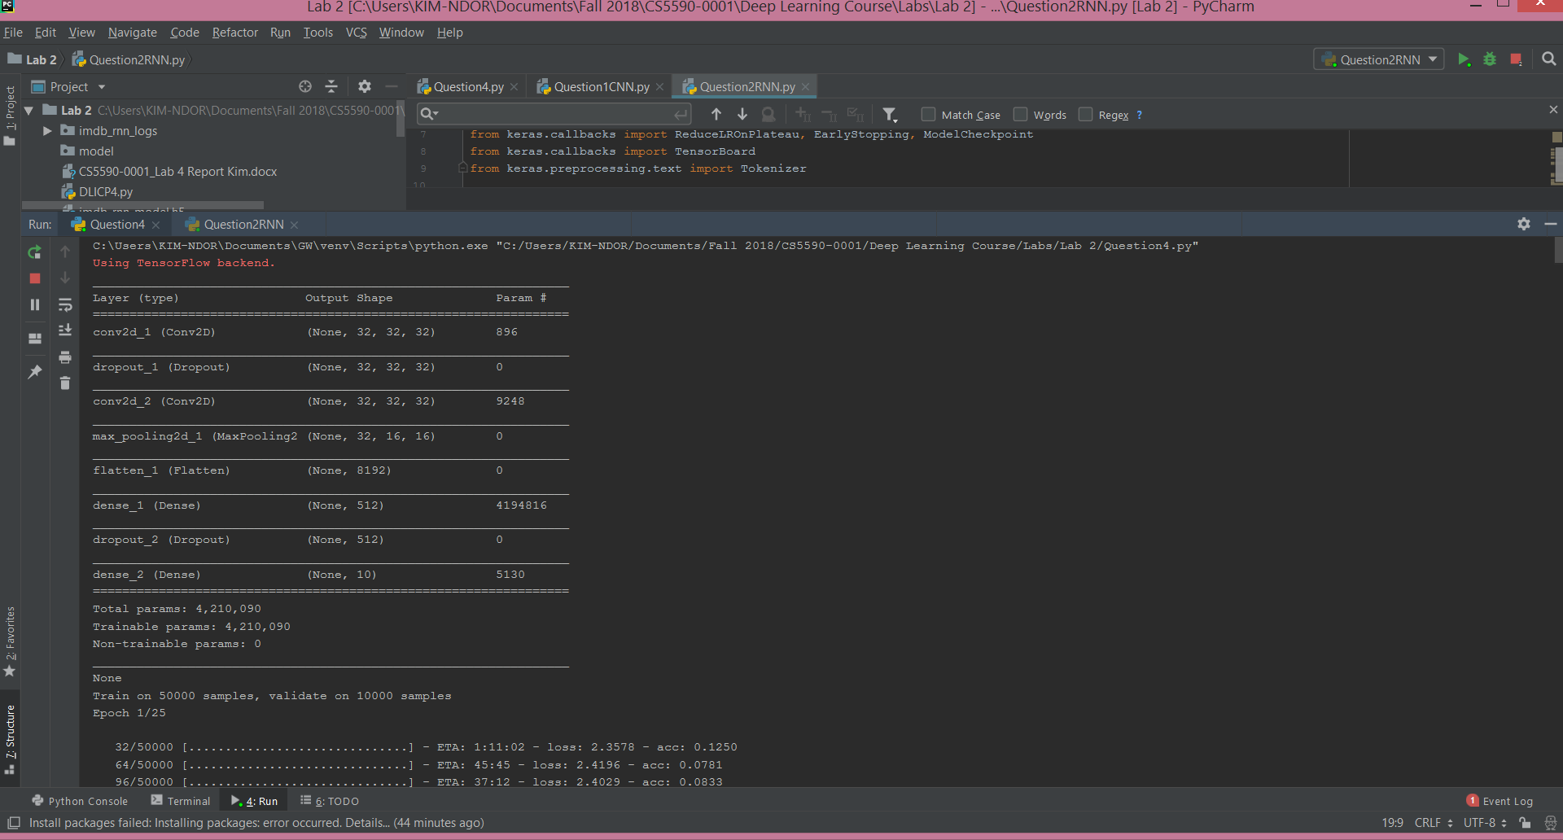

**Errors results**

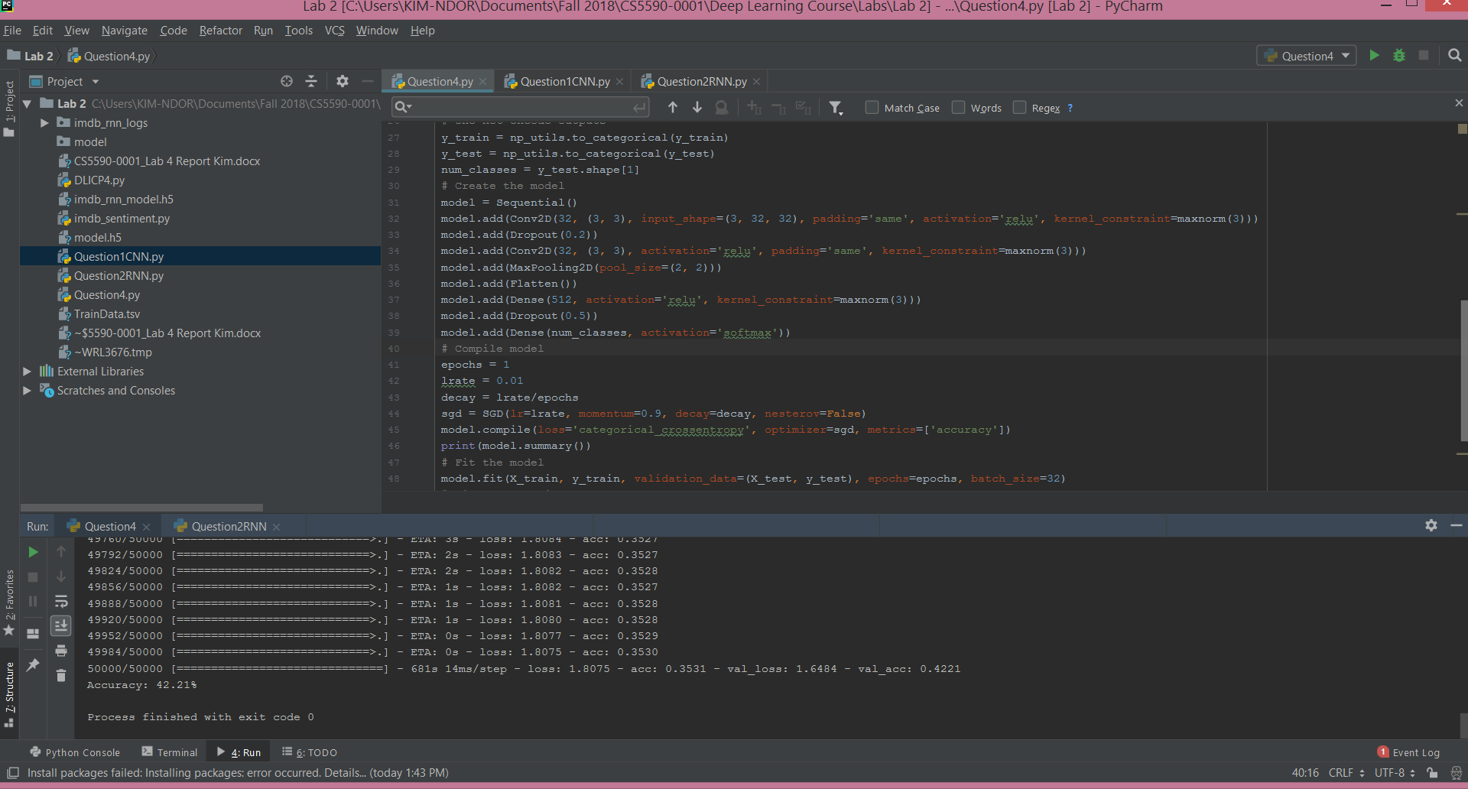

**References**

Class materials.